**Matthew McCool**

W16 E Century Towers Beijing China

matthew.mccool@shangri-la.com

**CAREER OBJECTIVE:** I have a strong interest in all areas of the food industry and pride myself on my ability to create a memorable dining experience via the presentation, quality and timeliness of each meal. Overseas experience has broadened the scope of cuisine I am able to deliver, and I now seek a higher position whereby I can apply this knowledge.

**KEY SKILLS & ATTRIBUTES:**

**Ability to:**

* plan menus and work out food labour costs
* order food, kitchen supplies and equipment
* select, train and manage staff
* manage large brigades
* demonstrate techniques to chefs and advise of cooking procedures
* plan staff rosters and supervise the activities of chefs and assistants
* explain and enforce hygiene regulations
* discuss food preparation issues with managers, dietitians and other staff members
* prepare and deliver a variety of cuisines

**EDUCATION & TRAINING:**

**2004 RESPONSIBLE SERVICE OF ALCOHOL (Cert No: 29543)**

MHM Australasia Pty Ltd

**2001 CERTIFICATE III IN HOSPITALITY (COMMERCIAL COOKERY)**

TAFE NSW Ourimbah Campus

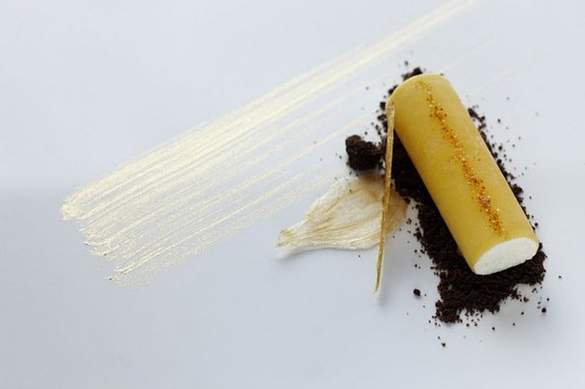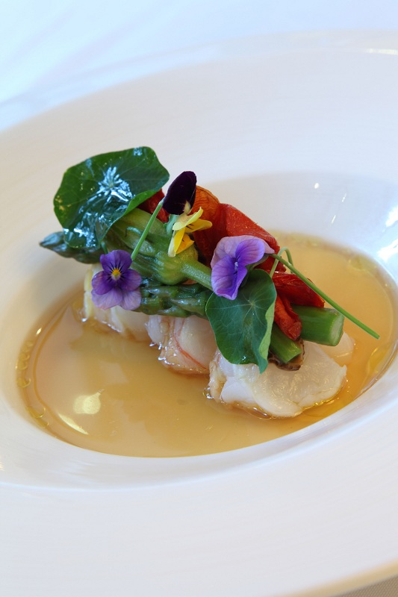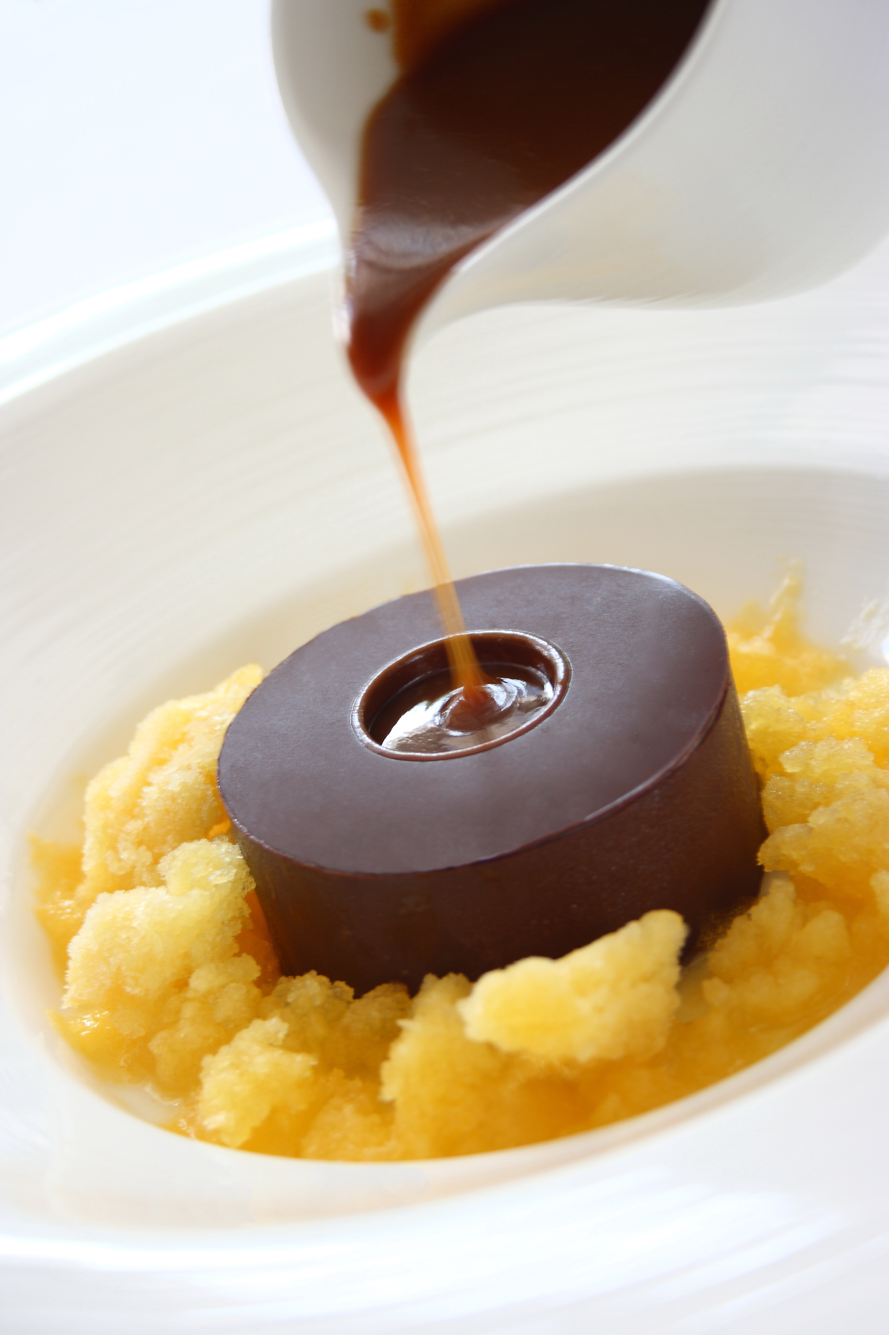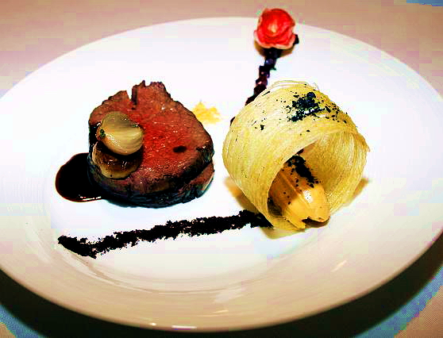

**EMPLOYMENT HISTORY**

**August 2010- Present 5 Star**

China world Hotel, Shangri-la Beijing

Chef de Cuisine

Aria Restaurant

90 seats

20 chefs

Modern European

**http://www.shangri-la.com/en/property/beijing/chinaworld/dining/restaurant/aria**

**June 2009- June 2010 1 Michelin Star**

Jnr sous chef

Chez Bruce

50 seats

12 chefs

French cuisine

**December 2007 - June 2009 1 Michelin Star**

Jnr sous chef

Tom Aikens London

15 chefs

Daily degustation menu.

**May 2006 – November 2007 1 Michelin Star**

Sous Chef

Bank Restaurant

London, UNITED KINGDOM

In charge of a brigade of 26 chefs

Ordering and menu changing

Training new employees

**January 2005 – April 2006 1 Michelin Star**

Sous Chef

Gordon Ramsey’s Maze

Grosvenor Square, London, England

In-Charge of ordering, cost control and menu ideas for tapas lounge

Chef saucier

70 covers

**October 2003 – December 2004**

Chef de Partie

Wildfire Sydney Pty Ltd

Circular Quay, SYDNEY

Fish section

Menu planning

Popular city restaurant

**January 2001 – October 2003 World top 50 Restaurants**

Quay Restaurant, SydneyPreparation and delivery of high quality restaurant cuisine

Beijing

The food at China World Hotel is considered by the doyens of catering in Beijing as some of the best among five-star hotels in the capital. There are still many pleasant surprises - such as the well-kept secret of Aria, the hotel's award-winning Western restaurant where the menu has remained unchanged for three years now.

But the winds of change are blowing with the arrival of Matthew McCool, new chef de cuisine. Born in Australia of Scottish descent, the 26-year-old's 10-year stint in the business is already considerable.

McCool was junior sous chef at the two-star Michelin restaurant Chez Bruce in London. In the year and a half he worked in Britain, he also worked at Gordon Ramsey's maze, a three-star Michelin restaurant.

The chef says he likes to incorporate all that he has learned in the past into his cuisine, including the influences of France, Italy and his native Australia.

|  |
| --- |
|  |
| **Matthew McCool, new chef of Aria in China World Hotel, incorporates entertainment with dining. Wang Jing / China Daily** |

"I try to bring a bit of different style from these European countries," McCool says.

He describes his style as a fusion between French techniques and Japanese and European produce.

"I like to use Japanese cooking for its freshness, and European for its strong, bold styles," he says.

Customers are seeing a lot of creative matches and novel presentations in a new dinner menu at Aria just out on Oct 8. For example, he often combines earthy ingredients such as a perfectly seared tuna with ponzu-flavored spaghetti. He will also pair Blackmore Wagyu, a juicy, marbled beef exclusive to Aria, with a coffee reduction, chocolate and macerated green olives.

Surprising food matches have become the chef's signature. A tender veal steak is served with a smoked foie gras cream to enhance the taste and texture of the meat.

Roasted sea bass is served with a variety of ingredients including roasted cauliflower, clams, prosciutto and fennel.

"The dining experience should be a show," McCool says. "A good restaurant should incorporate entertainment with dining."

His unique melted chocolate cake proves the point. An attentive waitstaff uses a heated spoon to pour hot chocolate over the cold chocolate crust, which melts to reveal a white chocolate center.

Another piece of theatrical tabletop drama is when the one-kilo slab of prime rib is presented to diners. The meat is attached to a huge bone, not unlike a dinosaur's. It serves two.

"I definitely won't try anything other people have done," McCool says.

The young chef has spent the past month in Beijing experimenting and tasting. He says his goal is to revamp Aria and make it the best in Beijing again. This is McCool's first time in China, and while he says most of his friends are happy for him, some have called him "crazy" for coming over here.

"From Europe to China is a big change, and a big challenge," he says. "But I'm glad I made the choice."